Frequently Asked Questions
Updated 8.12.26
Are couples allowed and what is the living situation?
Dorm areas are currently set up with a men’s side and women’s side for sleeping. The building will not have a hard curfew. There is a neutral area in the center of the floorplan, and it’s used for programming space that will have tables and seating for folks to enjoy.
Are pets allowed? Are there rules for that?
Yes, currently the plan is to accept pets. One pet per person, unless they are an emotional support animal and may allow up to 2. The pet must be with the person at all times and the owners can’t leave the pet behind unsupervised at the shelter. Owners may identify a person to be responsible for the pet in the owners absence. At a minimum, they will need a rabies vaccination to enter. Staff are working to establish a relationship with a veterinarian to assist. There may be additional requirements. There will licensing requirements but that will not prevent people from entering shelter.
How do we work with allergies and folks who are afraid of pets?
There will be temporary walls available to create space between people. We’ll try to accommodate allergies to the best of our ability.
Is the shelter open to all unsheltered people in the community?
Right now, we are working with the riverfront encampments in the first phase and eventually the emergency shelter will be open to other people experiencing homelessness.
What are the requirements for sobriety?
They can’t have items on site, but there’s no requirement for someone to be sober to enter as long as they are managing appropriate behavior. Staff will work with clients to meet them where they are and support them to ensure the environment is safe for everyone.
What accommodations for people who are in recovery?
There is no requirement for people to disclose their sobriety status. Program staff may be able to position bed assignments to support recovery. The shelter is working to identify programming options to support people in recovery knowing that this is a stressful experience that can trigger to relapse.

What are qualifications for shelter staff?
Preferred qualifications are people who have previous experience working in this field or related fields and/or lived experience. CASS does comprehensive onboarding and actively seeks training opportunities for all staff as we learn about the specific needs of our clients.
How many people are needed to open the shelter?
We expect to have enough staff to open on Sept. 1. Eleven is the minimum number of staff needed to open. Three staff will be on site at all times. There will also be a Shelter Supervisor and Director of Programming and custodial staff on the team.
How will we handle meals and food storage?
We’re working to solidify a plan to have breakfast and dinner. Guests may keep non- perishable items in the footlocker at the bedside. Food restrictions are to prevent pests that get attracted to open container and to keep the space clean and hygienic.
What is the intake process like?
Intake will be similar to PACEM and the Haven. There may be some additional questions for people who are 55 and up and experiencing cognitive decline so they may be connected to additional resources. Guests will enter in the center lobby area and check in and check out with staff to ensure beds are reserved.
Guests will need to check in by 8pm. Later check in times for people who need accommodations for working times will be coordinated with shelter staff.
What about storage? Will I be able to bring things to the shelter with me?
There will be a few options for storage at Holiday Drive. Each bed will have a footlocker with a lock to store everyday items. There will be also an indoor storage area for people to store and secure larger items that will be managed by staff and only accessible by request in order to protect everyone’s belongings. We are working to accommodate outdoor storage as well for larger items. There will be a process in place for staff to supervise and organize belongings and tag them for the person. 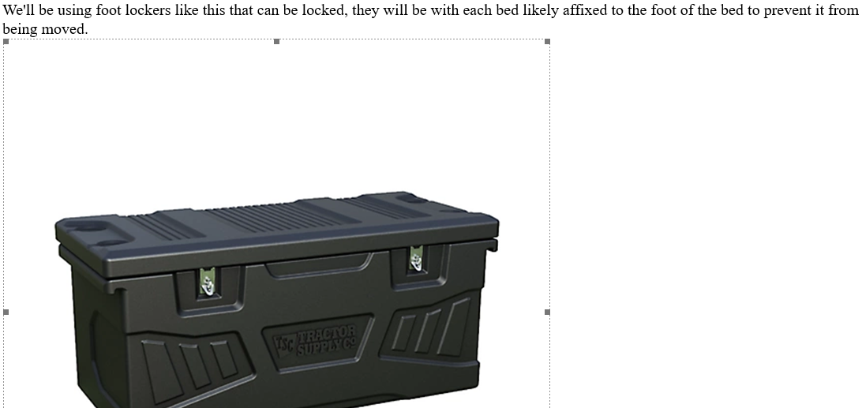

Will I have to take my stuff with me when I go out?
No, you will be able to leave your belongings at your assigned bed and in the footlocker.
Will there be access to Showers & Toilets?
Yes, we are working towards solutions and talking with vendors regarding outdoor portable toilets and showers.
Are linens and bedding provided?
Shelter staff will provide a bed, mattress, and linens. Staff are exploring additional solutions regarding bedding which may include having a ‘hotbox’ to ensure that bedding does not contain pests. Picture below is a sample of what the mattress will look like. We will not be using bunk beds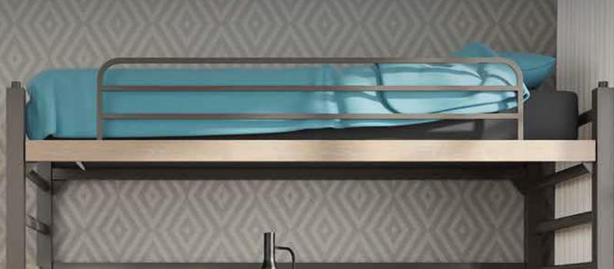.
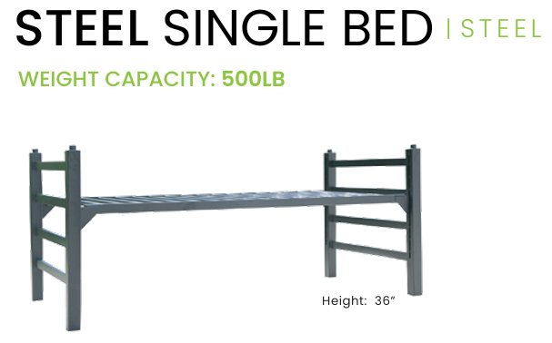
Will there be laundry services at Holiday Drive?
There will be laundry for staff to wash linens and bedding. Currently there will not be laundry services for guests based on current space restrictions. The Haven will continue their laundry services for guests.
What options will be provided for transportation?
Currently there is a bus stop at the intersection of Holiday Drive and Emmett Street. Bus Routes 7 and 8. Staff are working on solutions to provide shuttles from Holiday Drive, but that is not confirmed yet.

Will there be cameras at Holiday Drive?
Yes, the building will have cameras in common areas and storage areas. There is no plans for cameras in sleeping areas. Staff will provide supervision and support in those areas.
Will I lose my spot if I need to go to the hospital for medical treatment?
No, typically beds are held for hospital visits that are coordinated with shelter staff.
What items are not allowed at the shelter?
Item | Reason | Example
Fireworks or Explosives | Safety, Fire Hazard or otherwise illegal | Sparklers, firecrackers, bottle rockets, roman candles, smoke bombs, Improvised Explosive Device
Candles | Safety- Fire Hazard | Any kind of candle
Chemicals to include cleaning products and other flammable liquids | Safety- Odors, flammability risk, risk reaction with approved cleaning chemicals | Spray paint, WD40, liquid bleach, drain opener, ammonia, Single load size of laundry soap or dry bleach, pods, Charcoal fluid, lighter fluid
Lighter that can stay lit unattended | Safety- Fire Hazzard | Cigar, torch or zippo lighters.
CO2 Cannisters, Stove Fuel,  Aerosols | Safety- Fire hazard or explosive | For air gun  Any kind of Aerosol cans
Electrical extension cords surge protectors,  Electric Iron | Safety- Could lead to electrical circuit Overload. Fire hazard | Extension cords,  Electric Iron
Fighting Aids of any type | Potential Weapon- threat of violence | Num-chuks, brass knuckles, batons, bats, clubs, Throwing stars, chain 18 inches or longer.
Pepper Spray, Mace, Tear gas | Potential Weapon threat of Violence | Pepper Spray, Mace, Tear gas
Tools of trade, individual hand tools | Safety & Valuable property | Chef knifes, tool set of 3, power tools, hammers, wrench, screw drivers
Multi-tools with or without cutting blade,  Straight edge razors, Folding knife of any type or size | Potential weapons  Threat of violence | Pocket knives, Straight edge razors, Scissors, Switch blade knifes, Ice picks, fixed blade knifes, pot Hatchet, war axe, Cleaver
Small objects that would be a poor weapon | Weapon- threat of violence | Can opener, corkscrew, nail clippers. Cutical clippers
Any devices capable of shooting to projection, and ammunition for such weapons/devices | Weapon- threat of violence | Cross bow, sling shot, Taser, Stun guns, BB gun, Pellet gun, Airsoft gun, water gun, Bullets, BBs, pellets, paintball
Glass Items | Safety | Glass jars, cups, bottles of any sort including nail polish
Bungee cords with hooks | Safety | Bungee cords with hooks
Alcohol, illegal drugs or illicit substances | Safety | Alcohol of any sort,
Illegal drugs of any type in any form | Illegal by any federal, state, and local law | Illegal drugs of any type in any form
Marijuana all forms with or with out card. | Federal law CASS is federal funded | Marijuana all forms with or without card.
Open, non-perishable foods |  | Loafs of bread, raw meat, sandwich meat, soda in large bottles or >6 cans, cereal boxes, granola, fruits, donuts

